WEEK- 5:
Task 1: To Apply Single Quotes, Preserve Literal Content, Ignore Variable Expansion, Store Quoted Strings, Validate Parsing Results, Test Edge Cases.
Task 2: To Apply Double Quotes, Preserve Spaces, Allow Variable Expansion, Parse Nested Tokens, Validate Outputs, Test Quoted Commands

CODE:
#include <stdio.h>
#include <string.h>
int main()
{
char variable[] = "OSSP";
char single_quoted[] = "$variable";
char normal_text[] = "Hello OSSP";
printf("Single Quote Parsing Demonstration\n\n");
printf("Variable value : %s\n", variable);
printf("Single quoted string : '%s'\n", single_quoted);
printf("Normal string : %s\n", normal_text);
if (strcmp(single_quoted, "$variable") == 0)
{
printf("\nVariable expansion ignored.\n");
printf("Literal content preserved successfully.\n");
}
printf("\nParsing test completed.\n");
return 0;
}
OUTPUT:
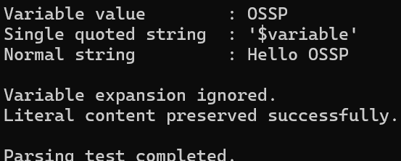
TASK-2:
CODE
#include <stdio.h>
#include <string.h>
int main()
{
char variable[] = "OSSP";
char quoted_string[] = "Operating Systems and Systems Programming";
printf("Double Quote Parsing Demonstration\n\n");
printf("Variable value : %s\n", variable);
printf("Quoted string : \"%s\"\n", quoted_string);
printf("\nVariable expansion:\n");
printf("Value inside double quotes: \"Hello %s\"\n", variable);
printf("\nPreserving spaces:\n");
printf("Quoted text: \"%s\"\n", quoted_string);
printf("\nNested token test:\n");
printf("Command: echo \"Hello %s\"\n", variable);
printf("\nParsing and validation completed successfully.\n");
return 0;
}
OUTPUT:
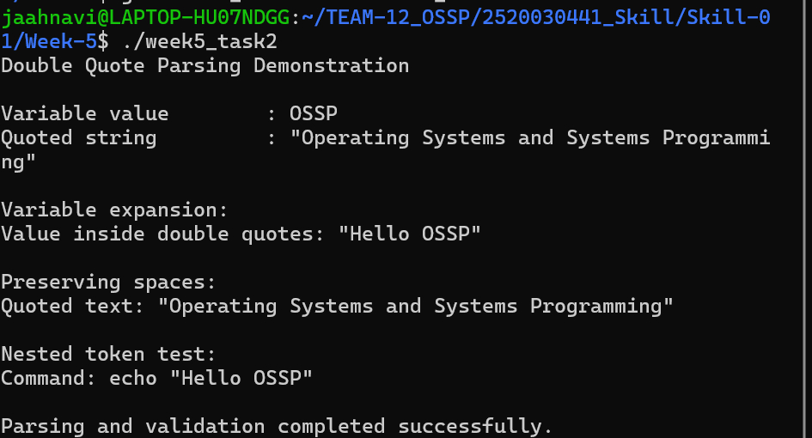

WEEK-6:
Task 1: To Create Process Escape Sequences, Handle Escaped Spaces, Escape Special Symbols, Preserve Characters, Validate Parser Output, Test Complex Inputs.
Task 2: To Create Child Processes, Execute Programs, Handle Execution Errors, Pass Arguments, Manage Parent Process, Test Command Launching.
CODE
#include <stdio.h>
#include <string.h>
void parse_escaped_input(const char *input)
{
int i = 0;
printf("Parsed output: ");
while (input[i] != '\0')
{
if (input[i] == '\\' && input[i + 1] != '\0')
{
i++;
printf("%c", input[i]);
} else
{
printf("%c", input[i]);
}
i++;
}
printf("\n");
}
int main()
{
char input[] = "OSSP\\ Lab\\;2026\\ \\$System\\\\Programming";
printf("Escape Sequence Parsing Program\n\n");
printf("Original input : %s\n", input);
parse_escaped_input(input);
printf("\nEscape sequences processed successfully.\n");
printf("Special characters and escaped spaces preserved.\n");
return 0;
}
OUTPUT: 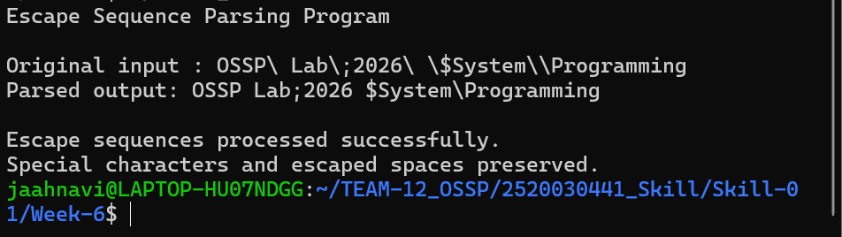
TASK-2
CODE
#include <stdio.h>
#include <stdlib.h>
#include <unistd.h>
#include <sys/wait.h>
int main()
{
pid_t pid;
printf("Process Execution Program\n");
printf("Parent PID: %d\n\n", getpid());
pid = fork();
if (pid < 0)
{
perror("fork failed");
return 1;
}
if (pid == 0)
{
printf("Child Process\n");
printf("Child PID: %d\n", getpid());
printf("Executing command: ls -l\n");
execlp("ls", "ls", "-l", NULL);
perror("Execution failed");
exit(1);
}
else
{
int status;
printf("Parent Process\n");
printf("Child PID: %d\n", pid);
printf("Waiting for child process...\n");
waitpid(pid, &status, 0);
if (WIFEXITED(status))
{
printf("\nChild process completed successfully.\n");
printf("Exit status: %d\n", WEXITSTATUS(status));
}
else
{
printf("\nChild process terminated unexpectedly.\n");
}
}
return 0;
}

OUTPUT
: 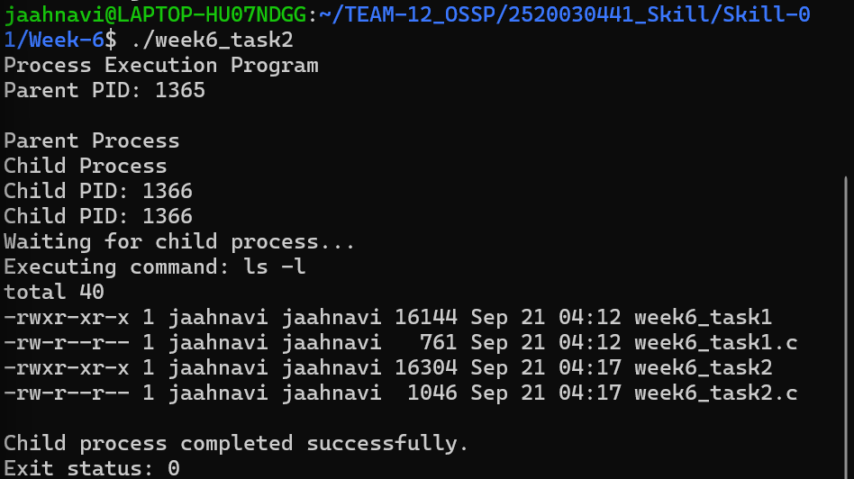
.

WEEK-7:

Task 1: Process Synchronization and Child Process Monitoring Using waitpid().

Task 2: To Retrieve PATH Variable, Parse Search Directories, Locate Executables, Verify Permissions, Handle Missing Commands, Test Command Resolution
CODE:
#include <stdio.h>
#include <stdlib.h>
#include <unistd.h>
#include <sys/wait.h>
int main()
{
pid_t child1, child2;
int status;
printf("Process Synchronization Program\n");
printf("Parent PID: %d\n\n", getpid());
child1 = fork();
if (child1 < 0)
{
perror("First fork failed");
return 1;
}
if (child1 == 0)
{
printf("Child 1 started\n");
printf("Child 1 PID: %d\n", getpid());
sleep(2);
printf("Child 1 completed\n");
exit(10);
}
child2 = fork();
if (child2 < 0)
{
perror("Second fork failed");
return 1;
}
if (child2 == 0)
{
printf("Child 2 started\n");
printf("Child 2 PID: %d\n", getpid());
sleep(1);
printf("Child 2 completed\n");
exit(20);
}
printf("Parent waiting for Child 1...\n");
waitpid(child1, &status, 0);
if (WIFEXITED(status))
{
printf("Child 1 terminated with exit status: %d\n",
WEXITSTATUS(status));
}
printf("\nParent waiting for Child 2...\n");
waitpid(child2, &status, 0);
if (WIFEXITED(status))
{
printf("Child 2 terminated with exit status: %d\n",
WEXITSTATUS(status)); }
printf("\nParent: All children synchronized successfully.\n");
return 0;
}

OUTPUT
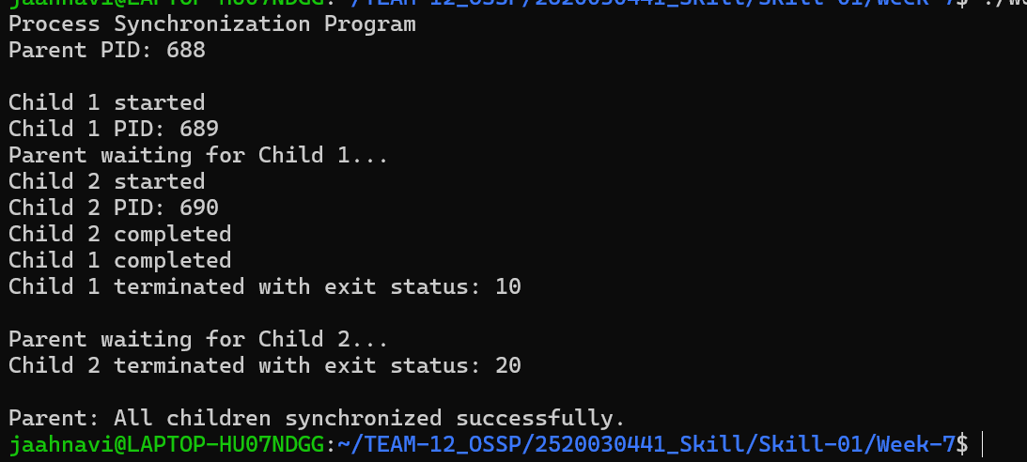

TASK 2
CODE
#include <stdio.h>
#include <stdlib.h>
#include <string.h>
#include <unistd.h>
#define MAX_PATH 4096
#define MAX_DIRS 100
int main()
{
char *path;
char path_copy[MAX_PATH];
char *directories[MAX_DIRS];
char *token;
char command[100];
char full_path[MAX_PATH];
int count = 0;
int i;
int found = 0;
printf("PATH Command Resolution Program\n\n");
path = getenv("PATH");
if (path == NULL)
{
printf("PATH variable not found.\n");
return 1;
}
strncpy(path_copy, path, MAX_PATH - 1);
path_copy[MAX_PATH - 1] = '\0';
token = strtok(path_copy, ":");
while (token != NULL && count < MAX_DIRS)
{
directories[count++] = token;
token = strtok(NULL, ":");
}
printf("Number of PATH directories: %d\n\n", count);
printf("Enter command to locate: ");
scanf("%99s", command);
for (i = 0; i < count; i++)
{
snprintf(full_path, sizeof(full_path),
"%s/%s", directories[i], command);
if (access(full_path, X_OK) == 0)
{
printf("\nExecutable found: %s\n", full_path);
printf("Execute permission: Available\n");
found = 1;
break;
}
}
if (!found)
{
printf("\nCommand '%s' not found in PATH.\n", command);
printf("Command resolution failed.\n");
}
else
{
printf("Command resolution successful.\n");
}
return 0;
}
OUTPUT
